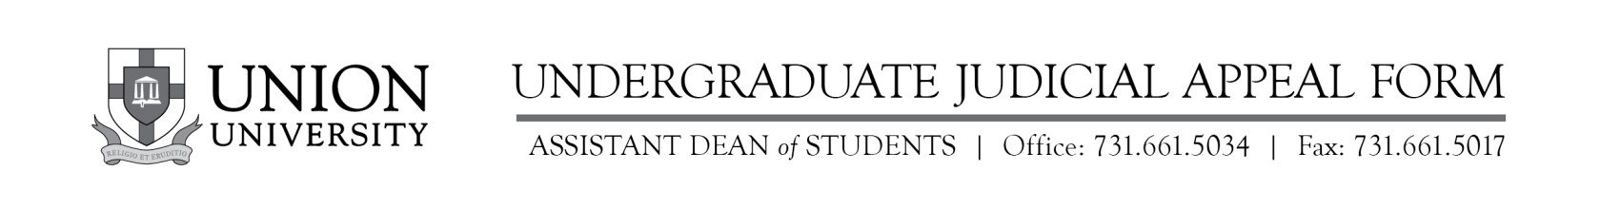

Union University offers an appeal process to all students who feel the facts surrounding their judicial meeting merit an appeal. This Appeal Form must be completed and returned to the Assistant Dean of Students within two (2) business days after receiving notice of disciplinary sanctions.

NAME: ____________________________________________ ID NO. _______________________
ADDRESS: __________________________________________________________________________
PHONE: (______)________________________ E-MAIL: ___________________________________
DATE OF INCIDENT: _____________________ TYPE OF VIOLATION; _______________________

The student may appeal a decision based on one of the following reasons:
(Please (√) all that apply.)

_____a. The treatment received was unjust.
_____b. All the facts in the situation were not considered.
_____c. The action taken was too severe for the behavior involved.
_____d. The student did not receive due process as outlined in the
Campus Life Handbook.

Attach to this Appeal Form a typed summary detailing the reason for the appeal. Students are not guaranteed an interview with the judicial council hearing the appeal. All judgments on an appeal may be made solely on the information written in the appeal. This information must be directly related to one of the four reasons listed above.

